Process of Critical Thinking



By Mohamed Firas Faisal

# Contents

* Introduction
* Critical thinking
* Characteristics of critical thinking
* Steps in critical thinking
  + Identify the problem
  + Research
  + Determine data relevance
  + Ask questions
  + Identify the best solution
  + Present your solution
  + Analyze your solution
* Ways to start thinking critically
* Benefits of critical thinking
* Mistakes people make in critical thinking
* Conclusion
* References

# Introduction

Welcome to this booklet on critical thinking. We will explore its essence, qualities, skills, methods, steps, and benefits. You will gain a deep understanding of critical thinking and how to avoid common pitfalls. The information is meticulously compiled from trusted sources with references provided in the chapter dedicated to references.

# 

# Critical thinking

Critical thinking is a complex and rigorous cognitive process characterized by the deliberate and purposeful exercise of intellectual discipline. It involves actively and adeptly conceptualizing, applying, analyzing, synthesizing, and evaluating information that is acquired through observation, personal experience, reflection, reasoning, or communication.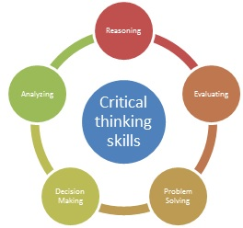

By engaging in this process, individuals are able to use their findings as a compass to navigate their beliefs and guide their actions. When executed skillfully, critical thinking encompasses a set of universal intellectual values that go beyond the confines of specific subject areas or academic disciplines. The values for effective critical thinking include clarity, accuracy, precision, consistency, relevance, sound evidence, good reasons, depth, breadth, and fairness.

By adhering to these intellectual values, individuals can unlock the full potential of critical thinking, cultivating a thoughtful and rigorous mindset that enhances their ability to approach problems, make informed decisions, develop well-founded beliefs, and take appropriate action. Critical thinking, when practiced in its exemplary form, empowers individuals to think critically and independently, enabling them to navigate the complex challenges of life with intellectual agility and confidence. (Firas #)

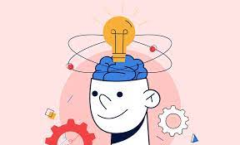

Critical thinking doesn't require pessimism or fixating on flaws. It means organizing thoughts to analyze and interpret situations or information, and then using that interpretation to make reasoned conclusions or judgments. It involves unbiased fact analysis and logical thinking, leading to more effective decision making and problem-solving. (Firas #)

# Characteristics of critical thinking



CURIOSITY

The purpose of critical thinking is to gather and assess the right information. Adopt the curiosity of a child and remove preconceived notions. Show humility. (Firas #)

AWARENESS

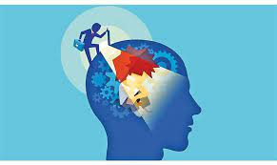

Is knowing what you know and knowing what you don't know.

Recognise our own assumptions

An effective critical thinker should be able to recognise their own blind spots (Firas #)

FLEXIBILITY

Be open to new information

Changes approach or perspective in response to unexpected obstacles or changing conditions.

Adapt easily and rapidly to new situations and new conditions (Firas #)

COMMON SENSE

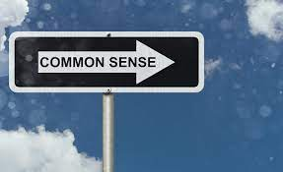

It helps you to spot a simple explanation for the situation or problem you have overlooked (it's not as easy or common as it sounds)

Common sense is about verification and accuracy.

Paying attention to the obvious (Firas #)

# Steps in critical thinking

### 1. Identify the problem

Before you put those critical thinking skills to work, you first need to identify the problem you’re solving. This step includes taking a look at the problem from a few different perspectives and asking questions like: 

* What’s happening?
* Why is this happening?
* What assumptions am I making?
* At first glance, how do I think we can solve this problem?

A big part of developing your critical thinking skills is learning how to come to unbiased conclusions. In order to do that, you first need to acknowledge the biases that you currently have.

### 2. Research

During the research process, collect information relating to the problem.. Make sure you gather information from a variety of sources, especially if those sources go against your personal ideas about what the problem is or how to solve it.

If you don’t get enough information, your ability to make a final decision will be skewed. Remember that critical thinking is about helping you identify the objective best conclusion. You aren’t going with your gut—you’re doing research to find the best option



### 3. Determine data relevance

Just as it’s important to gather a variety of information, it is also important to determine how relevant the different information sources are. After all, just because there is data doesn’t mean it’s relevant.

Once you’ve gathered all of the information, sift through the noise and identify what information is relevant and what information isn’t. Synthesizing all of this information and establishing significance helps you weigh different data sources and come to the best conclusion later on in the critical thinking process.

To determine data relevance, ask yourself:

* How reliable is this information?
* How significant is this information?
* Is this information outdated? Is it specialized in a specific field?

### 4. Ask questions

One of the most useful parts of the critical thinking process is coming to a decision without bias. In order to do so, you need to take a step back from the process and challenge the assumptions you’re making.

We all have bias—and that isn’t necessarily a bad thing. Unconscious biases often serve as mental shortcuts to simplify problem solving and aid decision making. But even when biases aren’t inherently bad, you must be aware of your biases in order to put them aside when necessary. 

Before coming to a solution, ask yourself:

* Am I making any assumptions about this information?
* Are there additional variables I haven’t considered?
* Have I evaluated the information from every perspective?
* Are there any viewpoints I missed?

### 5. Identify the best solution

Finally, you’re ready to come to a conclusion. To identify the best solution, draw connections between causes and effects. Use the facts you’ve gathered to evaluate the most objective conclusion.

Keep in mind that there may be more than one solution. Often, the problems you’re facing are complex and intricate. The critical thinking process doesn’t necessarily lead to a cut-and-dry solution—instead, the process helps you understand the different variables at play so you can make an informed decision.



### 6. Present your solution

Communication is a key skill for critical thinkers. It isn’t enough to think for yourself—you also need to share your conclusion with other project stakeholders. If there are multiple solutions, present them all. There may be a case where you implement one solution, then test to see if it works before implementing another solution.

### 7. Analyze your decision

The seven-step critical thinking process yields a result—and you then need to put that solution into place. After you’ve implemented your decision, evaluate whether or not it was effective. Did it solve the initial problem? What lessons—whether positive or negative—can you learn from this experience to improve your critical thinking for next time?

Depending on how your team shares information, consider documenting [lessons learned](https://asana.com/resources/lessons-learned) in a central source of truth. That way, team members that are making similar or related decisions in the future can understand why you made the decision you made and what the outcome was.

(“Build Critical Thinking Skills in 7 Steps w/ Examples [2023]”)



# Ways to start thinking Critically

Always vet new information with a cautious eye. Look at where the information has come from. Is the source trustworthy?

Consider more than one point of view. Everyone has their own opinions and motivations

Practice active listening. Listen carefully to what others are telling you, and try to build a clear picture of their perspective. Try to listen without judgment – remember, critical thinking is about keeping an open mind.

Gather additional information where needed. Whenever you identify gaps in the information or data, do your own research to fill those gaps.

Ask lots of open-ended questions. Curiosity is a key trait of critical thinkers

Find your own reputable sources of information. Try to avoid anonymous sources or sources with an ax to grind or a product to sell.

Try not to get your news from social media. And if you do see something on social media that grabs your interest, check the accuracy of the story (via reputable sources of information, as above) before you share it.

Learn to spot fake news. It's not always easy to spot false or misleading content, but a good rule of thumb is to look at the language, emotion, and tone of the piece.

Learn to spot biased information. Like fake news, biased information may seek to appeal more to your emotions than logic and/or present a limited view of the topic.

Question your own biases, too. Everyone has biases, and there’s no point pretending otherwise.

Form your own opinions. Remember, critical thinking is about thinking independently. So once you’ve assessed all the information, form your own conclusions about it.

(“Forbes”)



# Benefits of critical thinking

* Thinking independently
* Making better decisions
* Dealing with change quickly and effectively
* Solving problems systematically
* Thinking more creatively
* Increased self reflection
* Detect common mistakes and inconsistencies in reasoning
* Recognise your own assumptions and biases

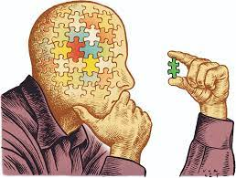

# 

# Mistakes made while thinking critically

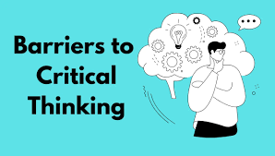

RATIONALISING

It's the opposite of logical thinking. It arises from a desire to avoid being wrong. When you think logically you start with the evidence then reach a conclusion, but when you rationalize you have a you want conclusion and then you find evidence to support that conclusion

Emotional Thinking

It means the absence of logic

Emotional thinking can happen when you react to a feeling or emotional language rather than the facts.

Wishful thinking: wishing in unrealistic belief in something simply because you wish it were true

Polarization

It is the emotional attachment to one side of an issue

To avoid it separate facts from feelings

BIASES

Bias is a preference, partiality or favoritism towards a certain point of view based on any of the following

Tunnel Vision

Tunnel vision occurs when we behave in a set way in certain patterns without considering or even realizing that there are other options outside of what we know/see. (Firas #)

# Conclusion

In conclusion, critical thinking is a skill that is required a lot in life. This booklet has highlighted all of the steps, characteristics and benefits of critical thinking

References

Works Cited

“Build Critical Thinking Skills in 7 Steps w/ Examples [2023].” *Asana*, 17 February 2023, https://asana.com/resources/critical-thinking-skills. Accessed 14 September 2023.

“Critical Thinking Skills: Definition, 7 Examples & How to Improve Them.” *HIGH5 Strengths Test*, https://high5test.com/critical-thinking-skills/. Accessed 14 September 2023.

Firas. *Notes*. Notes taken from class paraphrased using AI. 2023, Maldives. *Google docs*.

“13 easy ways to improve your critical thinking.” *Forbes*, Forbes, https://www.forbes.com/sites/bernardmarr/2022/08/05/13-easy-steps-to-improve-your-critical-thinking-skills/?sh=439744015ecd. Accessed 14 September 2023.